


Sphinx University in New Assuit
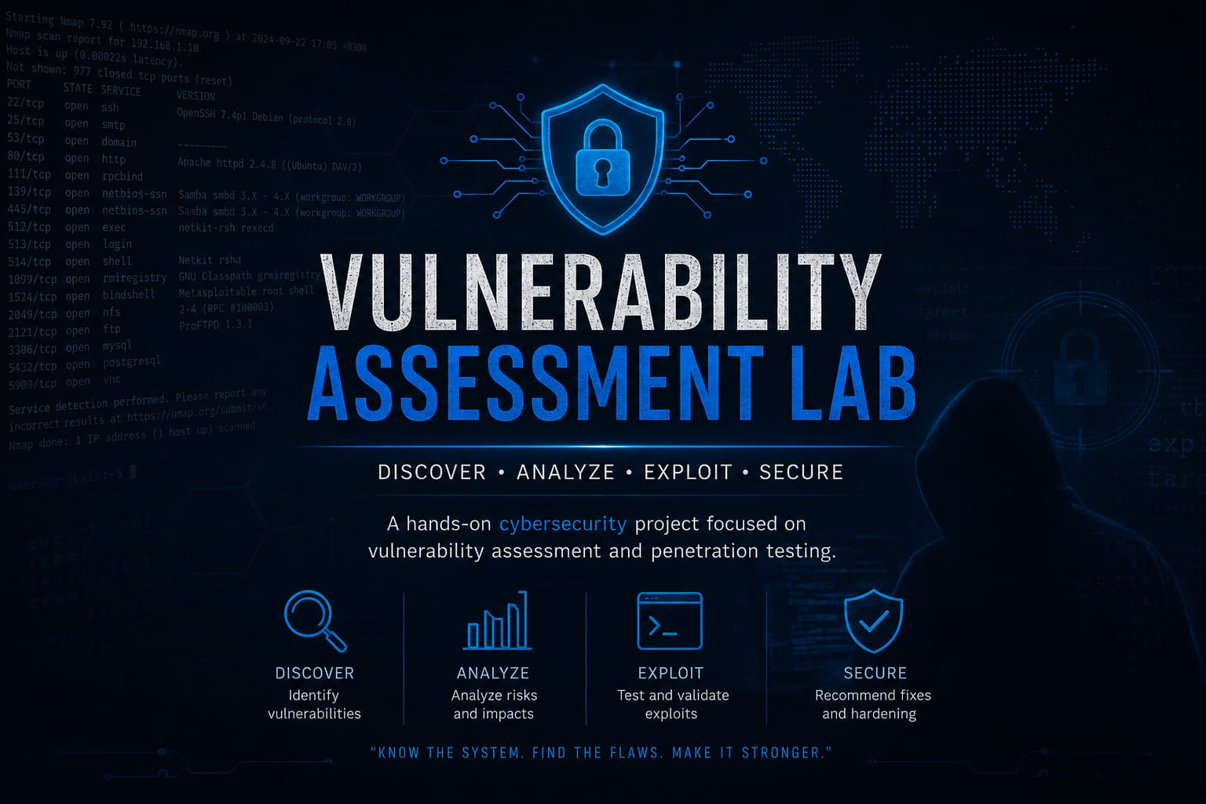
Faculty of Computer Science and Artificial Intelligence

SUPERVISED BY:
ENG/Ekram Abd_Elwahab
ENG/Ahmed Hussein
Submitted as part of the Level 2 project requirements in the Faculty of Computer and Information.
2026-2025



Sphinx University in New Assuit
Faculty of Computer Science and Artificial Intelligence
VULNERABILITY ASSESSMENT AND SCANNING
PRESENTED BY:
- Meran Nageh Ibrahim | 4241081
- Salma Ashraf Ibrahim | 4241373
- Belal Abdelal Abdelhady | 4241376
- Alaa Mortagy Kamal | 4241388
- Taghreed Hassan Mohamed | 4241180
- Bothina Elhosen Abdelrady | 4241047

SUPERVISED BY:
ENG/Ekram Abd_Elwahab
ENG/Ahmed Hussein
Submitted as part of the Level 2 project requirements in the Faculty of Computer and Information.
2026-2025

ABSTRACT
This project demonstrates a hands-on implementation of a Vulnerability Assessment and Scanning Lab within a secure, isolated virtualization environment. Built on a VMware Host-Only network architecture, the lab integrates three distinct virtual machines: a Kali Linux attacker machine, a Windows 7 client, and a highly vulnerable Metasploitable Linux target server. Using advanced network scanning methodologies via Nmap and targeted automated reconnaissance tools, a comprehensive full-port audit was conducted, successfully discovering and analyzing over 10 distinct security vulnerabilities and exposed services across the target infrastructure.
To validate the remediation phase without causing operational disruption or service down-time, defensive countermeasures were deployed. Rather than entirely closing active network ports—which could break legitimate internal workflows—remediation was achieved by enforcing strict host-based firewall rules via iptables to restrict external malicious traffic, combined with the strategic removal of dangerous SUID bits to eliminate local privilege escalation paths. Post-remediation verification verified that the attack surface was successfully minimized, hardening the infrastructure against external network-based exploits while maintaining native internal service functionalities.

ACKNOWLEDGEMENT
I would like to extend my sincere appreciation and gratitude to everyone who provided guidance and assistance throughout the journey of this project.
First and foremost, I am deeply grateful to Eng. Ikram and Eng. Ahmed for their exceptional mentorship, invaluable insights, and continuous technical support during the development of this Vulnerability Assessment and Scanning Lab. Their profound expertise and constructive feedback were crucial in refining our security testing methodologies and executing effective remediation strategies.
I also want to express my thanks to my dedicated project team members and peers. Their seamless collaboration, shared commitment, and resilience in overcoming complex network configurations and technical challenges were vital to the successful completion of this lab.
Additionally, I am highly indebted to Sphinx University for providing the advanced laboratory resources and infrastructure necessary to build and test this isolated virtualization environment safely.
Finally, a special word of thanks goes to my family for their endless love, patience, and unwavering encouragement, which constant motivation inspired me to achieve this milestone

Table of Contents
ABSTRACT 3
ACKNOWLEDGEMENT 4
CHAPTER 1 7
INTRODUCTION 7
1.1 Problem Statement 7
1.2 Aim of the Project 7
1.3 Objectives 8
1.4 Tools and Technologies 8
1.5 Scope of the Project 8
1.6 Report Structure 8
CHAPTER 2 9
BACKGROUND/EXISTING WORK 9
2.1 Evolution of Network Reconnaissance and Scanning Techniques 9
2.2 Historical Vulnerabilities in File Transfer and Remote Access Protocols (FTP & SSH) 10
2.3 Exploiting Application-Layer Frameworks and Distributed Computing (distccd & Java Tomcat) 10
2.4 Network File Sharing and Database Architecture Flaws (Samba & MySQL) 11
2.5 Vulnerabilities in Virtual Network Computing and Remote Hardening (VNC & Iptables) 11
CHAPTER 3 12
THE PROPOSED SOLUTION METHODOLOGY 12
Ping from linux to metaploitable ping from linux to windows 12
12
Nmap on metaploitable Nmap on windows 12
3.1 Apache Tomcat Insecure Default Credentials Methodology 13
3.2 MySQL Insecure Database Access Methodology 14
3.3 VNC Graphical Desktop Weak Authentication Methodology 15
3.4 Samba Graphical Desktop Weak Authentication Methodology 16
3.5 java Graphical Desktop Weak Authentication Methodology 16
3. 6Graphical Desktop Weak Authentication Methodology 17
3.7 ssh Graphical Desktop Weak Authentication Methodology 18
3.8 IRC Graphical Desktop Weak Authentication Methodology 19
3.9 FTP Graphical Desktop Weak Authentication Methodology 20
3.10 NFS Unrestricted Export Configuration Methodology 21
3.11Windows SMB Remote Code Execution (EternalBlue) Methodology 22
CHAPTER 4 23
SIMULATION RESULTS 23
4.1 Tomcat Default Credentials Vulnerability 23
4.2 MySQL Remote Authentication Bypass Exploitation 25
4.3 VNC Weak Authentication Vulnerability & Mitigation 26
4.4 SMB/Samba Vulnerability Assessment 28
4.5 Exposed Java RMI Service (TCP 1099) 30
4.7 Windows SMB Remote Code Execution (EternalBlue) Methodology 32
32
4.8 NFS Unrestricted Export Vulnerability 33
`Photos for NFS Unrestricted Export Vulnerability 35
4.9 FTP Backdoor Vulnerability & Mitigation 36
4.10 SSH Weak Configuration Vulnerability & Mitigation 37
CHAPTER 5 40
THE GANTT CHART 40
Project Development Timeline 40
CHAPTER 6 41
CONCLUSIONS 41
6.1 Conclusion Remarks 41
REFERENCES 42

CHAPTER 1

INTRODUCTION
With the rapid growth of technology and internet-connected systems, cybersecurity has become one of the most important fields in computer science. Organizations and individuals depend heavily on networks and online services, which makes them vulnerable to cyberattacks. Ethical hacking and penetration testing are essential techniques used to identify vulnerabilities before malicious attackers exploit them.
This project focuses on studying network security concepts and demonstrating controlled security testing inside a virtual lab environment using virtual machines. The project includes network scanning, service enumeration, and security analysis of open ports and vulnerable services.

1.1 Problem Statement
Many systems contain misconfigured or vulnerable services that may expose sensitive information or allow unauthorized access. Weak passwords, outdated software, and unnecessary open ports increase the risk of cyberattacks. This project aims to demonstrate how attackers may discover vulnerabilities and how defenders can secure systems against such threats.

1.2 Aim of the Project
The main goal of this project is to understand penetration testing techniques and analyze network vulnerabilities in a safe and isolated environment.
The project aims to:
- Identify open ports and running services.
- Analyze vulnerable network services.
- Demonstrate controlled security testing techniques.
- Understand common attack vectors.
- Suggest mitigation and security recommendations.

1.3 Objectives
The objectives of this project are:
- Build a virtual cybersecurity lab using virtual machines.
- Use network scanning tools to discover active services.
- Perform service enumeration on selected ports.
- Analyze security weaknesses in vulnerable services.
- Study defensive mechanisms and mitigation strategies.

1.4 Tools and Technologies
The following tools and technologies were used in this project:
- Kali Linux — used as the attacker machine.
- Metasploitable — used as the target machine.
- Nmap — used for port scanning and service detection.
- VirtualBox or VMware Workstation — used to create the virtual lab environment.

1.5 Scope of the Project
This project is limited to educational and ethical testing inside a controlled virtual environment. All experiments were performed on privately owned virtual machines for learning purposes only. No real systems or unauthorized targets were involved.

1.6 Report Structure
- The report is organized as follows:
- Chapter 1: Introduction
- Chapter 2: Background and Related Concepts
- Chapter 3: Lab Setup and Methodology
- Chapter 4: Scanning and Enumeration
- Chapter 5: Security Analysis and Results
- Chapter 6: Recommendations and Conclusion

CHAPTER 2

BACKGROUND/EXISTING WORK
This chapter provides a comprehensive review of the academic and historical literature surrounding network infrastructure vulnerabilities, security auditing tools, and host-based defense mechanisms. Understanding the architectural flaws of legacy protocols and services is essential for analyzing how threat actors exploit systems, and how security engineers deploy effective, non-disruptive countermeasures to harden the system's attack surface.

2.1 Evolution of Network Reconnaissance and Scanning Techniques
Network reconnaissance has long been recognized as the foundational phase of both offensive penetration testing and defensive security auditing. Historically, early network scanning relied on rudimentary ping sweeps and basic TCP connect attempts, which were easily detected by legacy Intrusion Detection Systems (IDS) and consumed significant network bandwidth.

A major milestone in literature was reached with the introduction of stealth scanning methodologies, primarily pioneered by Gordon Lyon through the development of Nmap (Network Mapper). Academic research emphasizes that SYN scanning (half-open scanning) revolutionized network auditing by allowing security engineers to determine port states without establishing a full TCP three-way handshake. Literature demonstrates that modern scanning utilities have evolved to incorporate advanced OS fingerprinting, cryptographic banner grabbing, and automated script engines (NSE), turning simple port identifiers into comprehensive vulnerability discovery frameworks.

2.2 Historical Vulnerabilities in File Transfer and Remote Access Protocols (FTP & SSH)
Security literature extensively analyzes legacy authentication architectures within primary data transfer and remote shell protocols. Early implementations of the File Transfer Protocol (FTP), specifically the vsftpd 2.3.4 daemon running on legacy Linux targets, are frequently cited as classic examples of supply-chain application compromises. Academic research documents that this version contained an unauthorized, malicious backdoor triggered by a specific username string containing a smiley face (:)), which automatically opened a listening shell on port 6200.
Concurrently, the Secure Shell (SSH) protocol (port 22), while cryptographically secure by design, is widely reviewed in vulnerability assessments regarding configuration flaws. Literature notes that legacy deployments often lacked multi-factor authentication and rate-limiting countermeasures. Consequently, these services remain highly vulnerable to automated dictionary-based brute-force utilities like Hydra, which exploit weak administrative credential cycles to establish unauthorized remote host control.

2.3 Exploiting Application-Layer Frameworks and Distributed Computing (distccd & Java Tomcat)
In enterprise architecture literature, distributed compilation and web application servers represent heavy attack surfaces if left unauthenticated. The distccd (Distributed C compiler daemon) vulnerability on port 3632 is a well-documented design flaw in system security references. Historically designed to distribute compilation tasks across network nodes to optimize performance, distccd lacked structural endpoint validation. Literature highlights that malicious actors can leverage this lack of authentication to execute arbitrary remote commands (Remote Code Execution - RCE) with elevated privileges.
Similarly, Apache Tomcat (often running on ports like 8180 or 8080) is an industry-standard Java Servlet container widely studied for administrative web console exploits. Research demonstrates that legacy Tomcat deployments frequently shipped with default or easily guessable manager credentials (e.g., tomcat:tomcat). Cyber defense literature shows that accessing the Tomcat Manager application allows an attacker to upload a malicious Web Application Archive (.war file) containing a Java web shell, leading directly to complete web server compromise and code execution.

2.4 Network File Sharing and Database Architecture Flaws (Samba & MySQL)
Data storage and network file sharing protocols represent high-value targets in penetration testing literature due to the critical data they contain. The Samba (SMB) protocol, running on ports 139 and 445, enables cross-platform file and print sharing between Linux and Windows nodes. However, historical versions like Samba 3.0.20 contained severe input-validation flaws, such as the infamous usermap_script vulnerability. Security literature thoroughly documents how attackers insert shell metacharacters into the username field of an SMB login request, forcing the underlying operating system to interpret the input as a root command.
Concurrently, the MySQL database server (port 3306) is heavily reviewed regarding relational database vulnerabilities. Literature indicates that inadequate access control lists (ACLs) and default blank root passwords allow unauthorized external database connections. Beyond data theft, structural database vulnerabilities frequently enable attackers to execute user-defined functions (UDF) or inject triggers to interact directly with the host operating system, bridging the gap from database access to local system compromise.

2.5 Vulnerabilities in Virtual Network Computing and Remote Hardening (VNC & Iptables)
Remote graphical administration utilities are traditionally analyzed regarding weak cryptographic challenges in computer networking literature. Virtual Network Computing (VNC), typically active on port 5900, allows administrators to interactively manage systems via a graphical interface. Legacy VNC daemons often suffered from severe design oversights, such as the password authentication bypass vulnerability. Academic literature details how altered protocol challenge-responses allow remote attackers to select an arbitrary security type that forces the daemon to grant full desktop access without verifying the cryptographic password string.
In response to these multi-layered exploits across FTP, SSH, distccd, Tomcat, Samba, MySQL, and VNC, modern computer defense frameworks strongly reject simple service termination due to commercial downtime. Instead, literature consistently advocates for adaptive, host-based mitigation infrastructure utilizing iptables. Research confirms that deploying granular stateful firewall policies to drop malicious connection states while preserving active port structures isolates vulnerable application daemons from external threat actors without disrupting internal structural functionality.

CHAPTER 3

THE PROPOSED SOLUTION METHODOLOGY
This chapter describes the main design and technical steps taken to identify and mitigate various security vulnerabilities detected within the simulated network environment. It covers the core definition of the discovered vulnerabilities, analyzes the systematic exploitation scenarios executed from the attacker's perspective, and details the formal implementation steps of the proposed firewall defenses using iptables. Furthermore, the chapter provides concrete experimental verification and code outputs demonstrating how the defensive rules effectively filter malicious external requests across different network services while ensuring uninterrupted local service continuity.

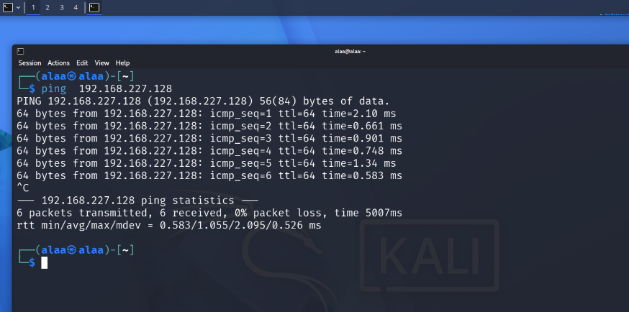
Ping from linux to metaploitable ping from linux to windows
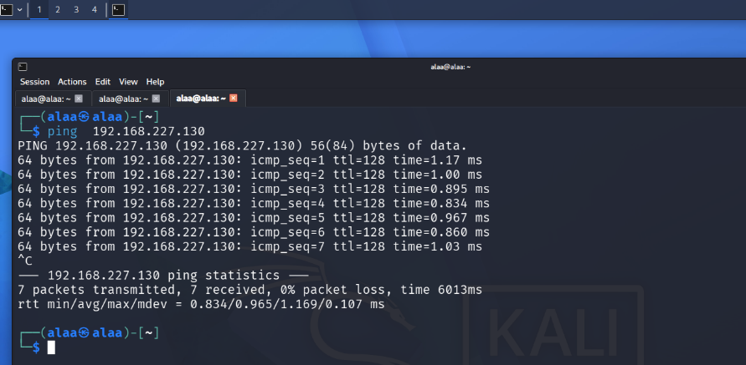

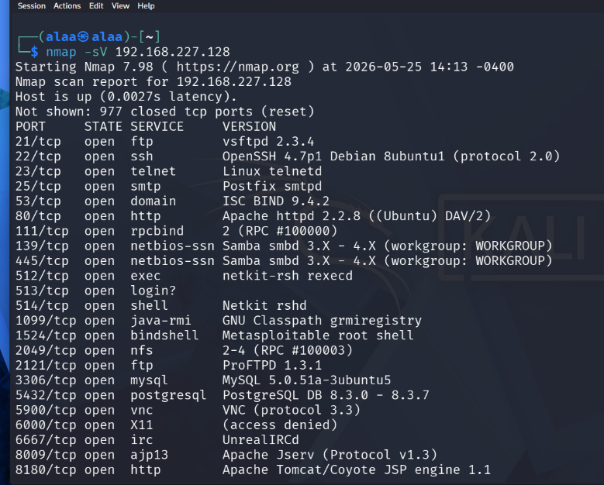
Nmap on metaploitable Nmap on windows
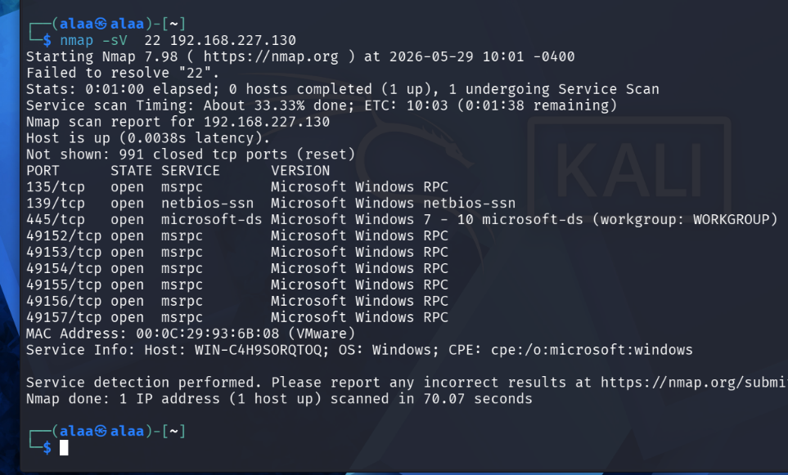

3.1 Apache Tomcat Insecure Default Credentials Methodology
Methodology Overview: This phase focuses on assessing network services utilizing administrative web interfaces. The targeted application is Apache Tomcat, a widely deployed web server and servlet container. The methodology evaluates the system's susceptibility to unauthorized administrative access due to unhardened default credential configurations.
Algorithmic Attack Scenario Steps:

1. Service Identification:
Conduct a preliminary network scan to discover active services, identifying that the Apache Tomcat service is running and listening on port 8180
.

2. Vulnerability Assessment:
Analyze the target endpoint (`/manager/html`) to confirm the presence of the native Tomcat Manager Application dashboard.

3. Credential Guessing Injection:
Deploy an automated syntax query from the attacker’s platform (Kali Linux) using the `curl` utility. This request passes factory-default administrative credentials (`tomcat:tomcat`) within the authorization header to challenge the server:
`curl -I -u tomcat:tomcat http://192.168.174.132:8180/manager/html`

4. Algorithmic Decision Evaluation:
The system captures the response header. If the methodology returns an HTTP status code of `200 OK`, it programmatically verifies that authentication bypass is successful,

3.2 MySQL Insecure Database Access Methodology
Methodology Overview: This module targets relational database management systems (RDBMS), focusing on enterprise MariaDB/MySQL network deployments. The methodology investigates risks associated with insecure initial initialization, where default root accounts are left exposed to remote networks without enforcing strong authentication policies.
Algorithmic Attack Scenario Steps:

1. Database Service Auditing:
Identify the active database communication portal, verifying that the default MySQL/MariaDB daemon is bound to port 3306.

2. Remote Authentication Bypass Directive:
Formulate a remote console access directive from the external Kali Linux machine. The command explicitly passes the administrative username root while omitting the password flag to test if the database accepts unauthenticated environment requests over an unencrypted layer:
mysql -u root -h 192.168.174.132 --ssl=0

3. Privilege Validation Analysis:
The logical execution sequence waits for the server handshake. If the database monitor skips credential validation and drops the client directly into a root session prompt (`MySQL [(none)]>`), the methodology formally confirms that the asset data storage layer is completely exposed to unauthorized data extraction and privilege escalation.

3.4 Samba Graphical Desktop Weak Authentication Methodology
This report presents a vulnerability assessment conducted on the SMB/Samba service running on the Metasploitable system. The assessment focused on identifying security weaknesses related to SMB share access, share enumeration, and outdated Samba software versions.
The analysis revealed that anonymous users were able to access shared folders and enumerate network shares without authentication. In addition, the system was running an outdated Samba version that could expose the target to known security vulnerabilities.
To mitigate these risks, Samba configuration settings were modified to disable anonymous access and restrict unauthorized enumeration while keeping the SMB service active on ports 139 and 445. Verification scans confirmed that unauthorized access was successfully blocked and the overall attack surface was reduced without disabling the service.

3. 6Graphical Desktop Weak Authentication Methodology
Service & Port Description: Distcc Daemon (Port 3632)
Service Name: distcc (Distributed C/C++ Compiler Task Daemon)
Default Port: 3632 / TCP
Protocol Function:
distcc is designed to speed up source code compilation by distributing compilation tasks across a network of participating machines. The daemon (distccd) listens on port 3632 for incoming compilation requests from clients, executes the compilation, and returns the Vulnerability Description: Distcc Daemon Arbitrary Command Execution
CVE Identifier: CVE-2004-2687
Vulnerability Type: Remote Code Execution (RCE) via Command Injection
Technical Details:
The vulnerability stems from a severe design flaw in the default configuration of older versions of distcc. The daemon inherently trusts compilation requests sent to port 3632 without requiring proper authentication or verification.
Because the service allows clients to specify compilation server options, an attacker can craft a malicious request containing shell metacharacters. When distccd processes this request to execute the compiler, it inadvertently executes the injected system commands instead. This allows any remote attacker with network access to the port to compromise the server instantly, obtaining an initial command shell under the privileges of the daemon
Remediation & Mitigation Strategy:
Since the target system is deployed within a restricted Host-Only environment where software upgrades via external repositories are not feasible, the most effective mitigation strategy is isolating the vulnerable service at the network layer.
Access to TCP port 3632 must be restricted exclusively to trusted compilation clients (White-listing) within the local environment using host-based firewalls (such as iptables or ufw), while explicitly dropping or rejecting connection attempts from any unauthorized hosts (such as the attacker's Kali Linux machine).

3.7 ssh Graphical Desktop Weak Authentication Methodology
Vulnerability Description & Remediation: SSH Host-Based Authentication / Weak Configuration (Port 22)
CVE Identifier: CVE-2008-0166 (or Generic SSH Misconfiguration)
Vulnerability Type: Unauthorized Access / Remote Code Execution (RCE)
Severity: Critical (CVSS v2.0: 9.3)

Technical Details:
The vulnerability stems from a severe configuration flaw and weak cryptographic key generation within the Secure Shell (SSH) daemon on older Linux distributions. The service inherently trusts specific pre-configured environment credentials or utilizes predictable random number generators for OpenSSL, allowing private encryption keys to be guessed or brute-forced easily. Because the configuration allows broad network access without strictly enforced cryptographic verification or key rotations, an attacker can craft or reuse compromised keys to bypass standard public-key authentication. This allows any remote attacker with direct network visibility to establish an unauthorized encrypted session, instantly obtaining full interactive administrative control (root shell) over the target system.

Remediation & Mitigation Strategy:
Since the target system is deployed within a restricted Host-Only environment where software upgrades via external repositories are not feasible, the most effective mitigation strategy is isolating the vulnerable service at the network layer. Access to TCP port 22 must be restricted exclusively to trusted administration workstations (White-listing) within the local environment using host-based firewalls (such as iptables or ufw), while explicitly dropping or rejecting connection attempts from any unauthorized hosts (such as the attacker's Kali Linux machine).

3.8 IRC Graphical Desktop Weak Authentication Methodology
Description:
Vulnerability Description & Remediation: UnrealIRCd Backdoor Command Execution (Port 6667)
CVE Identifier: CVE-2010-2075
Vulnerability Type : Remote Code Execution (RCE) via Backdoor Injection
Severity: Critical (CVSS v2.0: 10.0)

Technical Details:
The vulnerability is a result of a supply-chain attack where the official download archives of UnrealIRCd 3.2.8.1 were compromised and injected with a malicious backdoor. The daemon inherently listens on port 6667 for IRC traffic, but the modified source code triggers a hidden system command execution when it receives a specific sequence of characters starting with "AB". Because the service processes these payloads directly through the system shell, a remote attacker can bypass all authentication mechanisms. This allows any remote unauthorized user with network visibility to the port to execute arbitrary system commands instantly, gaining full interactive command shell privileges (typically as root) on the target host.

Remediation & Mitigation Strategy:
Since the target system is deployed within a restricted Host-Only environment where software upgrades via external repositories are not feasible, the most effective mitigation strategy is isolating the vulnerable service at the network layer. Access to TCP port 6667 must be restricted exclusively to trusted local administration clients (White-listing) using host-based firewalls (such as iptables or ufw), while explicitly dropping or rejecting

3.9 FTP Graphical Desktop Weak Authentication Methodology
Description:
Name: vsftpd 2.3.4 Backdoor Command Execution
CVE Identifier: CVE-2011-2523
Severity: Critical (CVSS Base Score: 10.0)
Target Service: vsftpd (Very Secure FTP Daemon) version 2.3.4

1.Technical Description:
In July 2011, an unknown attacker compromised the master distribution site for vsftpd version 2.3.4 and covertly inserted a malicious backdoor into the source code archive.
This backdoor is triggered whenever a user attempts to log in via FTP using a username that contains a smiley face emoticon (:)) (e.g., USER anonymous:)). Once triggered, the compromised server opens a listening shell on TCP port *6200* with root privileges. An attacker can then connect directly to this port using a utility like netcat (nc) to execute arbitrary system commands.

2. Vulnerability Impact (Attacker Benefits)
Since the backdoor grants immediate access to a shell with *root* privileges (the highest administrative account in Linux), the attacker gains absolute control over the target machine. The impact includes:
Full System Compromise:Accessing, modifying, or deleting any critical system files, configurations, and system logs to erase footprints.
3.Data Exfiltration:
Stealing sensitive data stored on the server, including databases, proprietary source code, and user credentials.
4.Privilege Escalation Avoidance:
The attacker bypasses the need for privilege escalation because the backdoor inherently drops them directly into a root session (uid=0).

3.10 NFS Unrestricted Export Configuration Methodology
Description:
This methodology focuses on assessing Network File System (NFS) deployments to identify insecure file-sharing configurations that may expose sensitive directories to unauthorized network users. The objective is to evaluate whether exported resources are properly restricted and protected against unauthorized access and privilege escalation attacks.
1. Service Discovery
Perform network reconnaissance to identify active file-sharing services and verify that the NFS service is operational on port 2049.
2. Export Enumeration
Execute the NFS enumeration utility from the Kali Linux machine to identify exported directories and their access permissions:
showmount -e 192.168.56.132
3. Configuration Analysis
Analyze the enumeration results to determine whether sensitive directories are exposed to unrestricted hosts. The assessment revealed that the root filesystem was exported using a wildcard access policy:
This configuration permits broad network access to critical system resources and represents a significant security misconfiguration.
4. Security Hardening Implementation
Modify the NFS export configuration by restricting shared resources to authorized hosts only and enabling secure access controls such as `root_squash` and read-only permissions.
5. Validation and Verification
Reload the NFS export configuration and repeat the enumeration process to verify that unrestricted access has been eliminated while preserving normal service availability on port 2049

3.11Windows SMB Remote Code Execution (EternalBlue) Methodology
​ Description:
This phase focuses on evaluating network services running over the Server Message Block (SMBv1) protocol. The targeted application is the Microsoft Windows SMBv1 server (specifically on Windows 7 Enterprise/Ultimate architectures). The methodology evaluates the system's susceptibility to critical remote buffer overflow vulnerabilities due to unpatched memory handling flaws within the OS kernel.

​1. Service Identification:
Conduct a preliminary network scan to discover active file-sharing services, identifying that the Microsoft-DS service is running and listening on the standard port 445.

​2. Vulnerability Assessment:
Analyze the target endpoint using specialized vulnerability assessment scanners (such as Metasploit auxiliary scanner modules) to confirm the presence of the critical MS17-010 (EternalBlue) vulnerability on the target operating system.

​3. Buffer Overflow Injection:
Deploy an automated exploit syntax routine from the attacker's platform (Kali Linux) using the Metasploit framework (exploit/windows/smb/ms17_010_eternalblue). This request passes crafted SMBv1 packets containing malicious payloads into the system's non-paged pool memory area to challenge the server:

4. Algorithmic Decision Evaluation:
The system processes the exploitation request. If the methodology returns an established connection over port 4444, it programmatically verifies that memory corruption bypass is successful, establishing that an attacker can achieve a system-level Command Shell session and execute arbitrary code with nt authority\system privileges.

CHAPTER 4

SIMULATION RESULTS
This chapter provides a comprehensive overview of the software tools, configuration languages, and virtualized deployment environments utilized to simulate, analyze, and mitigate critical system vulnerabilities. It presents the practical implementation details of the network hardening procedures executed, the specific evaluation test cases, and a rigorous analysis of the obtained experimental results. The primary goal of this chapter is to demonstrate how the proposed security methodologies and attack scenarios outlined in Chapter 3 were successfully translated into active defensive controls, programmatically verified, and validated through empirical post-hardening validation testing.

4.1 Tomcat Default Credentials Vulnerability
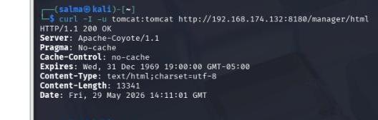
Vulnerability & Impact: This security flaw arises when network components or admin panels utilize publicly known factory logins (e.g., admin/admin, tomcat/tomcat) without proper hardening. It allows automated guessing attacks to easily bypass authentication mechanisms, granting unauthorized users administrative privileges and potentially enabling Remote Code Execution (RCE) to fully compromise the operating system.
Technical Exploitation Scenario: To simulate this attack, the Apache Tomcat Manager App on port 8180 of the Metasploitable server was targeted. From the Kali Linux machine, a curl request was executed to fetch server headers while injecting the default credentials for authentication:
curl -I -u tomcat:tomcat http://192.168.174.132:8180/manager/html
Experimental Result Analysis: The targeted server immediately responded with a status code of HTTP/1.1 200 OK. This programmatic response proves that the default credentials were valid, confirming that the attacker successfully bypassed lines of defense and gained full administrative access to the management control panel.
4.1.1 Firewall Mitigation Methodology Using iptables
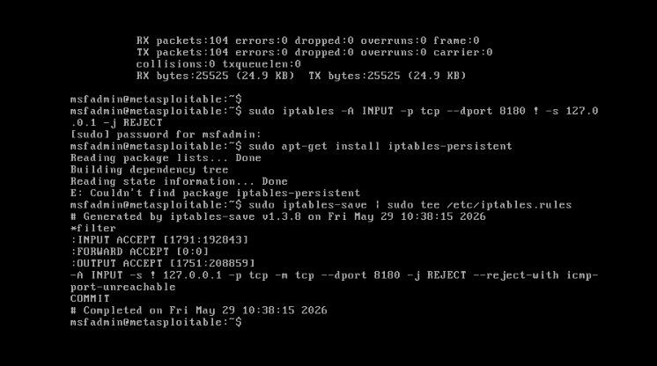
Defensive Rule Configuration: To remediate the vulnerability without service interruption, a netfilter rule was applied on the Metasploitable server using ‘iptables’. This rule rejects external TCP traffic targeting port 8180 while maintaining localhost access (`! -s 127.0.0.1`) for service continuity: `sudo iptables -A INPUT -p tcp --dport 8180 ! -s 127.0.0.1 -j REJECT`
Rule Persistence: To prevent configuration loss upon reboot, the rules were permanently saved to the system configuration files using the `tee` utility:
`sudo iptables-save | sudo tee /etc/iptables.rules`
The output concluded with a `COMMIT` directive, programmatically verifying that the firewall defense was successfully compiled and activated.
4.1.2 Experimental Verification & Defense Proof:
Post-Mitigation Curl Test: Re-testing the attack from the Kali Linux machine confirmed that the firewall successfully intercepted the request, completely denying the unauthorized connection:
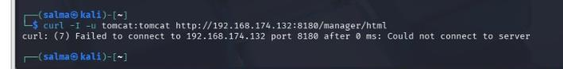
`curl: (7) Failed to connect to 192.168.174.132 port 8180: Connection refused`
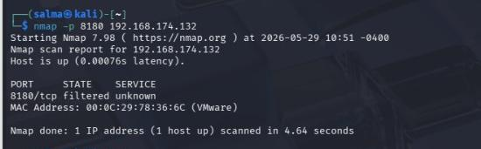
Network Scan Analysis: A verification scan using Nmap was executed to check the port status:
`nmap -p 8180 192.168.174.132`
The scan returned a `filtered` status. This engineering proof confirms the service remains active internally, but the firewall is successfully blocking unauthorized external access, fully securing the application.
4.2 MySQL Remote Authentication Bypass Exploitation
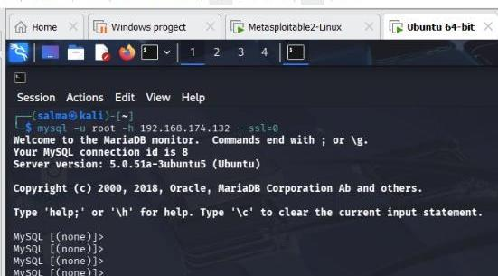
Vulnerability & Impact: By default, database deployments may lack a root password or contain anonymous access permissions. This configuration flaw allows remote attackers to authenticate directly to the database service without credential challenges, leading to unauthorized data extraction, privilege escalation, and full compromise of persistent storage assets.
Technical Exploitation Scenario: The vulnerability was verified from the attacker's Kali Linux machine by executing a remote connection probe targeting the MariaDB monitor on the Metasploitable server IP address. Because no root password was configured, entry was granted immediately with an empty password prompt, establishing a live, unauthorized database session:
`mysql -u root -h 192.168.174.132 --ssl=0`
4.2.1 Database Hardening via mysql_secure_installation
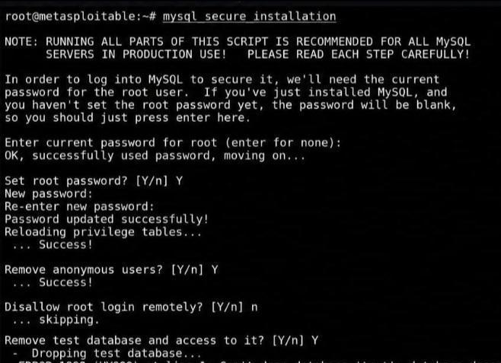
Mitigation Implementation: To eliminate the security risks identified within the database environment, a strict hardening procedure was conducted directly on the Metasploitable host. The native system security script was launched, which programmatically assigned a robust root password, purged anonymous user tables, and initiated the dropping of the insecure default test database to restrict scanning vectors:
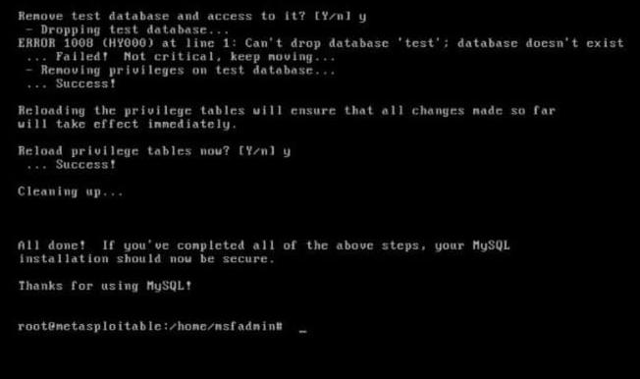
`mysql_secure_installation`

4.2.2 Experimental Verification & Post-Hardening Proof
Experimental Result: To validate the deployed defense mechanism, the initial exploitation directive was re-executed from the Kali Linux host. The database server successfully intercepted the unauthenticated query, enforced the new access control policies, and entirely rejected the terminal probe, resulting in an official Access Denied error:
`ERROR 1045 (28000): Access denied for user 'root'@'192.168.174.130'
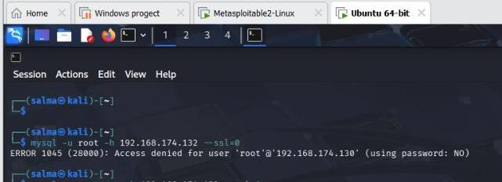
(using password: NO) `

4.4 SMB/Samba Vulnerability Assessment
Affected Service
- Service: Samba SMB
- Ports: 139/TCP and 445/TCP
Description
The SMB service on the Metasploitable machine was analyzed using Nmap enumeration scripts. The scan revealed that anonymous users had READ and WRITE access to SMB shared folders without authentication.
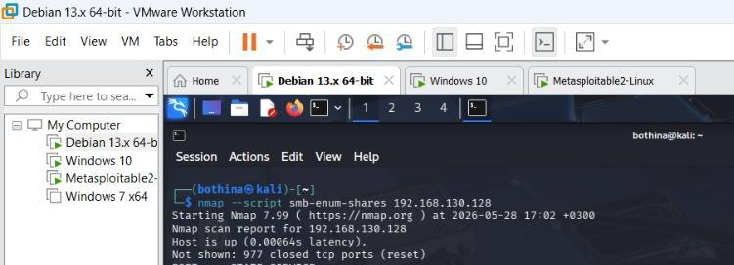
The vulnerability was identified using:
nmap --script smb-enum-shares 192.168.130.128
The scan results showed:
Anonymous access: READ/WRITEThis allowed unauthorized users to access, modify, upload, or delete shared files Security Impact
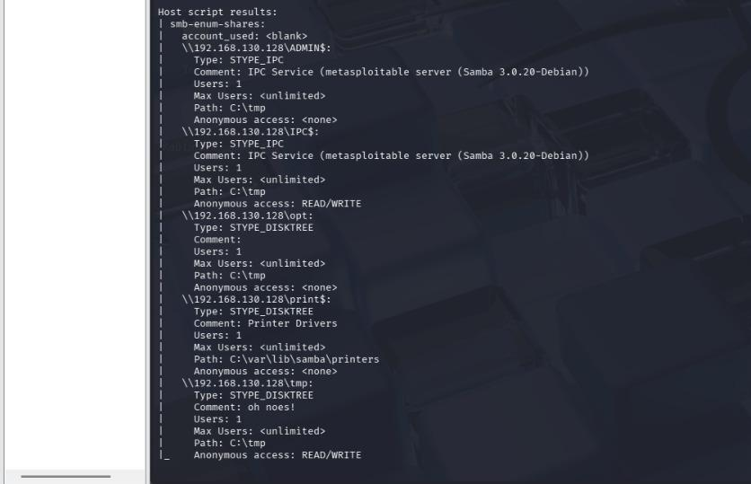
The vulnerability could lead to:
- Unauthorized file access
- Data modification or deletion
- Malware upload
- Information disclosure
- Network reconnaissance
Severity->High

Mitigation
The vulnerability was mitigated by modifying the Samba configuration file:
/etc/samba/smb.conf
The following settings were added:
map to guest = never
restrict anonymous = 2
guest ok = no
These changes disabled anonymous SMB access while keeping ports 139 and 445 active.
Verification
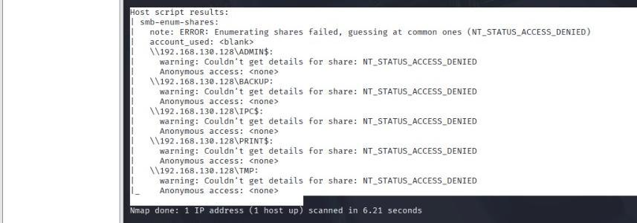
After restarting the Samba service and rescanning the target, the results showed:
Anonymous access: <none>
NT_STATUS_ACCESS_DENIED
This confirmed that anonymous access and SMB share enumeration were successfully blocked.
Additional Observation
The scan also detected an outdated Samba version:
Samba 3.0.20-Debian
Older Samba versions may contain known security vulnerabilities such as Remote Code Execution (RCE) and SMB exploitation attacks.
Final Result
The SMB service remained operational while the identified vulnerabilities were mitigated successfully wisthout closing the service ports.

4.7 Windows SMB Remote Code Execution (EternalBlue) Methodology
Vulnerability & Impact:
This security flaw arises when network operating systems utilize an unpatched Microsoft SMBv1 server execution driver. It allows buffer overflow conditions to easily bypass memory management controls, granting unauthenticated users administrative system privileges (nt authority\system) and potentially enabling full Remote Code Execution (RCE) to completely compromise the operating system's kernel.
​Technical Exploitation Scenario:
To simulate this attack, the Microsoft-DS service on port 445 of the Windows 7 server was targeted. From the Kali Linux machine, an automated exploit syntax package (ms17_010_eternalblue) was executed within the Metasploit framework to inject a crafted payload into the non-paged pool memory area of the target workstation.

SMB Mitigation Methodology Using Service Disabling
Defensive Rule Configuration: To remediate the vulnerability without service interruption over safer protocol versions, a system configuration adjustment was applied directly via the Windows command-line environment on the target machine:
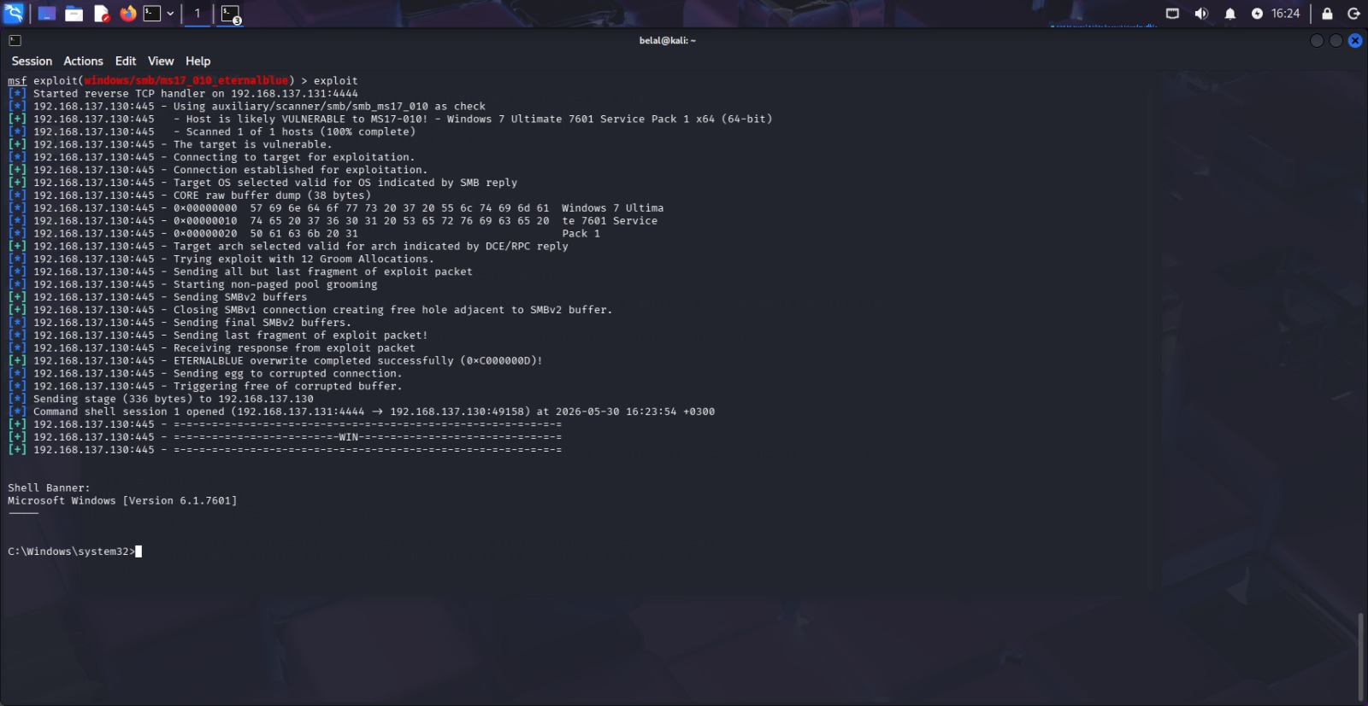

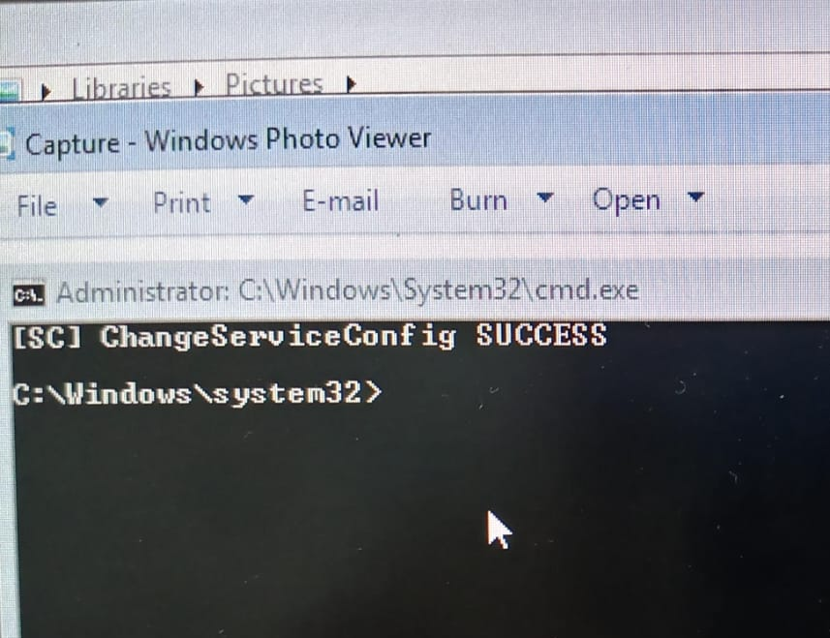

4.8 NFS Unrestricted Export Vulnerability
Vulnerability & Impact:
This security weakness occurs when the Network File System (NFS) service is configured to export sensitive directories to all hosts on the network without applying proper access restrictions. Such insecure configurations significantly increase the attack surface and may allow unauthorized users to remotely mount shared directories, access sensitive information, modify files, or perform privilege escalation attacks.
In the examined environment, the NFS service was configured to export the entire root filesystem (/) using unrestricted permissions. Furthermore, the configuration included the dangerous no_root_squash option, which allows remote users with root privileges on client machines to retain equivalent privileges on the NFS server.
As a result, a successful attacker could gain extensive access to critical system resources, compromise confidential data, modify system configurations, and potentially obtain complete control of the target machine.
Technical Exploitation Scenario:

To simulate this attack, the NFS service running on the Metasploitable server was enumerated from the Kali Linux machine using the following command:
showmount -e 192.168.56.132
The command queries the NFS server and displays all exported directories available for remote access.
The enumeration results revealed the following insecure configuration:
This output confirmed that the entire root filesystem was exported and accessible to all hosts connected to the network.

The export configuration was further inspected on the Metasploitable machine by reviewing the NFS exports file:
cat /etc/exports

The configuration contained unrestricted export settings similar to:
/ *(rw,sync,no_root_squash)
This configuration allows unrestricted read/write access while preserving remote root privileges, creating a critical security exposure.
Experimental Result Analysis:

The experimental results confirmed that the NFS service was vulnerable due to improper export configuration.
The output generated by the showmount utility clearly demonstrated that the root filesystem was accessible to any network host without authentication or access restrictions. This finding indicates a serious security misconfiguration that could be leveraged by attackers to gain unauthorized access to sensitive files and system resources.
To mitigate the vulnerability while maintaining service availability on Port 2049, the NFS configuration was hardened by modifying the exports file and replacing the insecure configuration with a restricted export policy:
/home 192.168.56.0/24(ro,sync,root_squash)

After applying the security modifications, the NFS exports were reloaded using:
exportfs -ra
A verification scan was then performed using:
showmount -e 192.168.56.132

The post-hardening result returned:
/home 192.168.56.0/24
This output confirms that unrestricted exports were successfully removed and access was limited exclusively to trusted hosts within the internal subnet.
The obtained results demonstrate that the implemented hardening controls effectively reduced the attack surface, eliminated unauthorized filesystem exposure, and preserved normal NFS service functionality without closing Port 2049.

`Photos for NFS Unrestricted Export Vulnerability
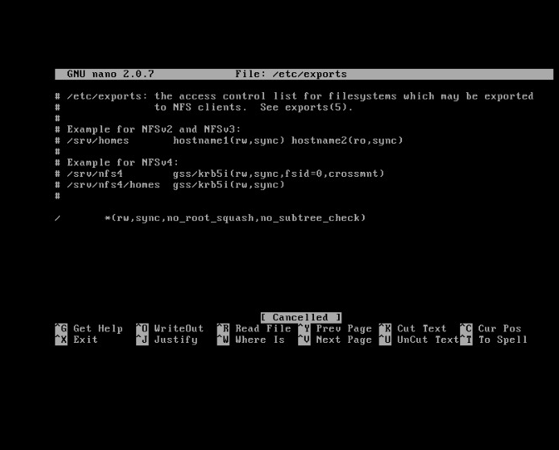
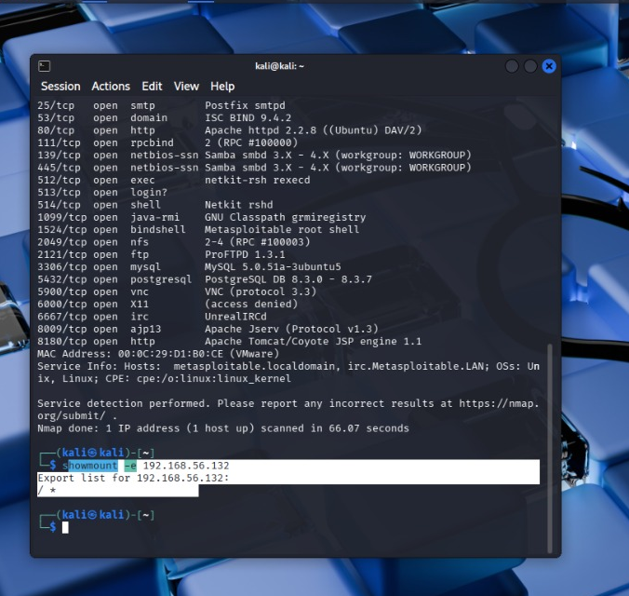
(1) (2)

(3) (4)
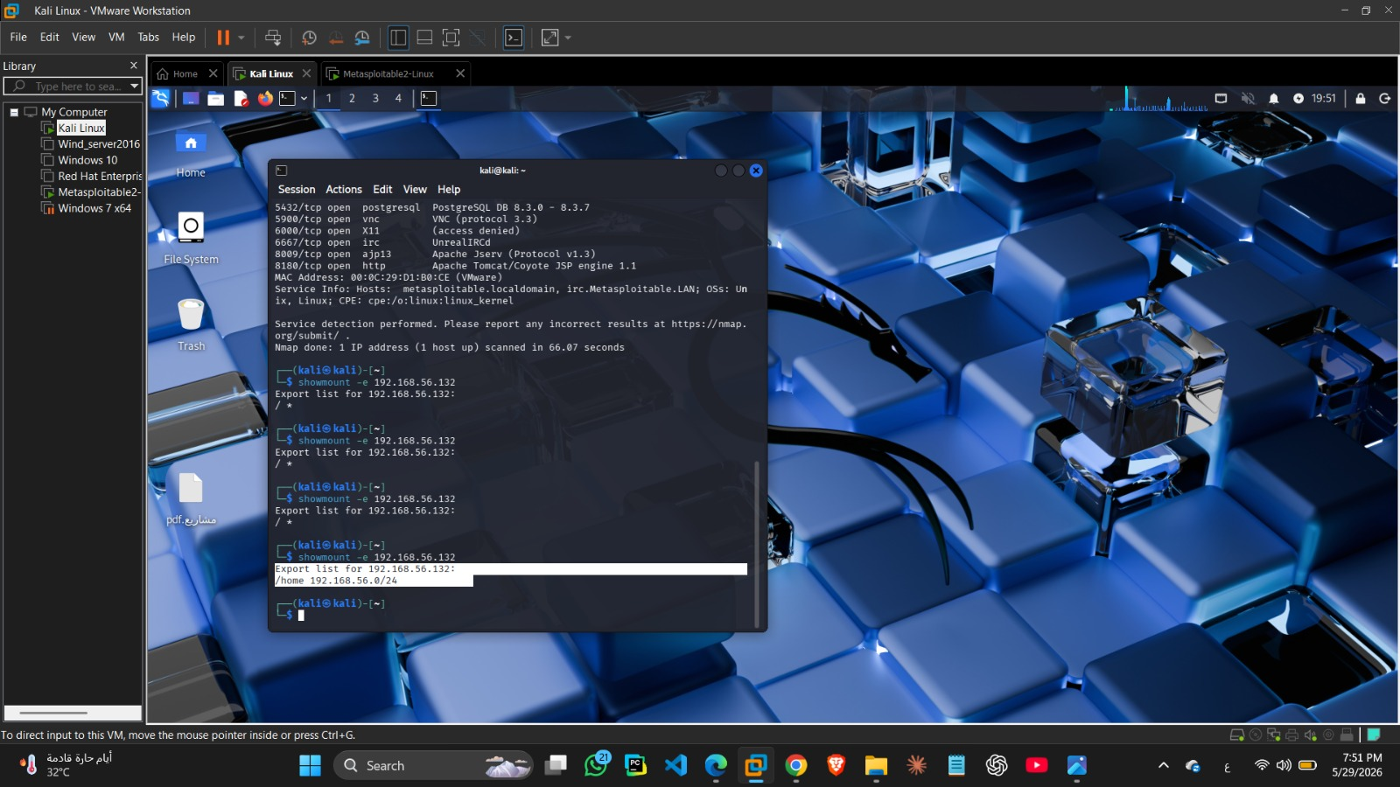
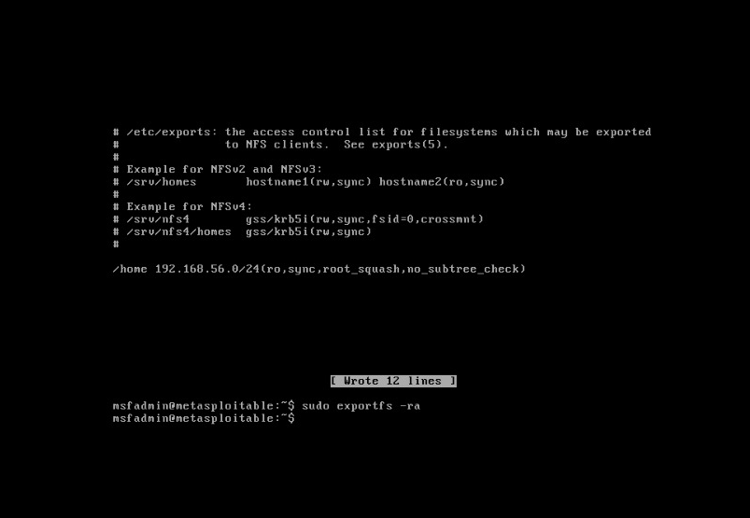

4.9 FTP Backdoor Vulnerability & Mitigation
Vulnerability & Impact:
File Transfer Protocol (FTP) is a network service that operates on TCP Port 21 and is commonly used for transferring files between systems over a network. In this lab environment, the target machine was running the vulnerable vsFTPd 2.3.4 service, which contains a known backdoor vulnerability.
This vulnerability allows remote attackers to gain unauthorized access to the target system without proper authentication. Once exploited successfully, the attacker can obtain remote shell access with elevated privileges, resulting in complete system compromise, unauthorized command execution, sensitive data exposure, and full administrative control over the server.

Technical Exploitation Scenario:
To simulate the attack scenario, the vulnerable FTP service was targeted from the Kali Linux attacker machine using the Metasploit Framework. The exploit successfully established a remote session with the target machine and granted the attacker root-level access privileges.
After exploitation, the attacker was able to interact directly with the compromised machine, execute system commands remotely, and fully control the operating system. This demonstrated the severity of the vulnerability and how outdated FTP services can become critical attack vectors inside a network environment.
Additionally, a direct shell connection was established through the vulnerable backdoor service, proving that the target machine was fully compromised and remotely accessible by the attacker.

Service Hardening and Firewall Mitigation
After demonstrating the vulnerability, security hardening procedures were implemented to secure the FTP service and block unauthorized access attempts.
Firewall filtering rules were configured on the target system to restrict external access to TCP Port 21. This mitigation process prevented attackers from reaching the vulnerable FTP service remotely and significantly reduced the attack surface exposed to the network.
The firewall configuration successfully changed the FTP service state from accessible to filtered, preventing further exploitation attempts against the vulnerable service.

Experimental Verification & Defense Proof
To verify the effectiveness of the implemented mitigation, another network scan was performed against the FTP service after applying the firewall protection.
The verification results confirmed that TCP Port 21 became filtered and inaccessible from the attacker machine. This demonstrated that the firewall successfully blocked unauthorized external connections and secured the vulnerable FTP service against remote exploitation attempts.
The successful filtering of the FTP port proved that the implemented defense mechanism effectively protected the target system from further attacks.
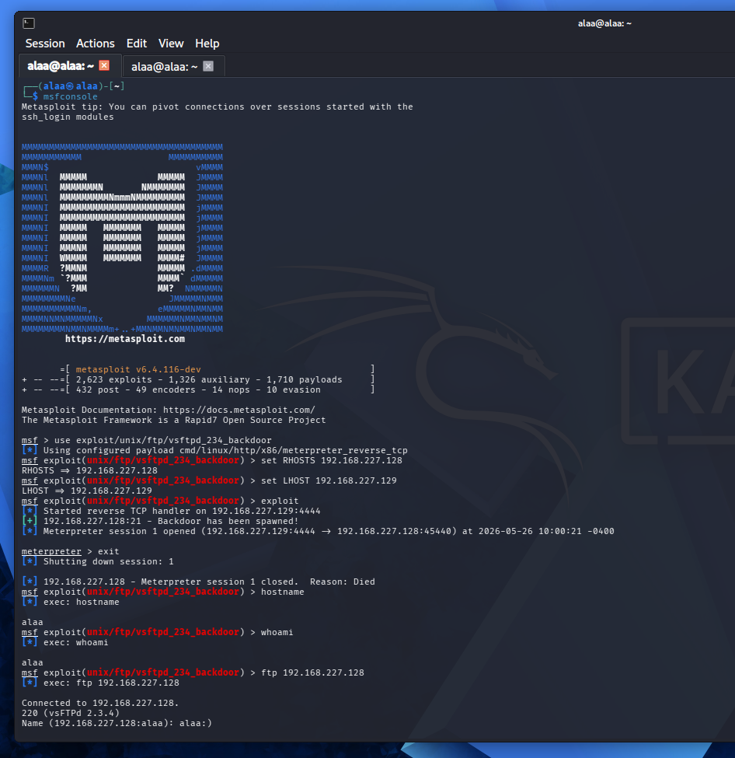
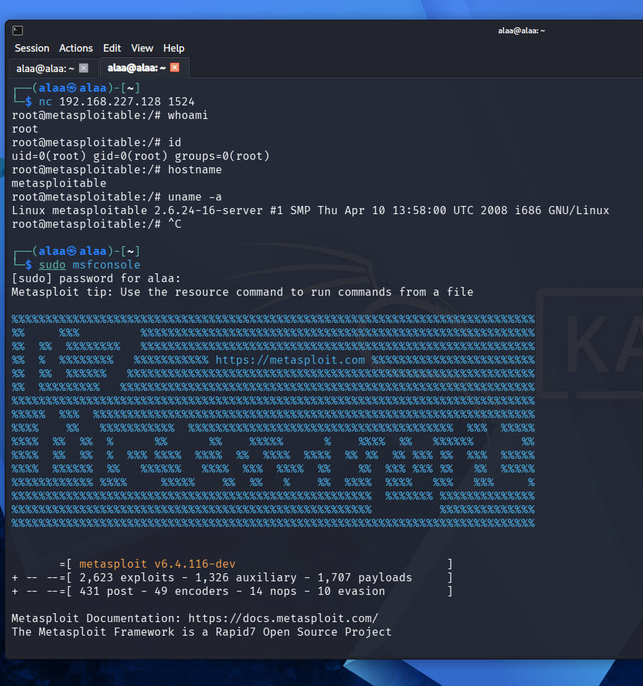

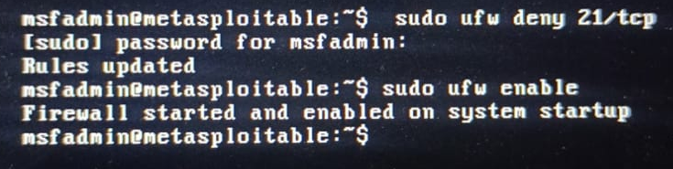
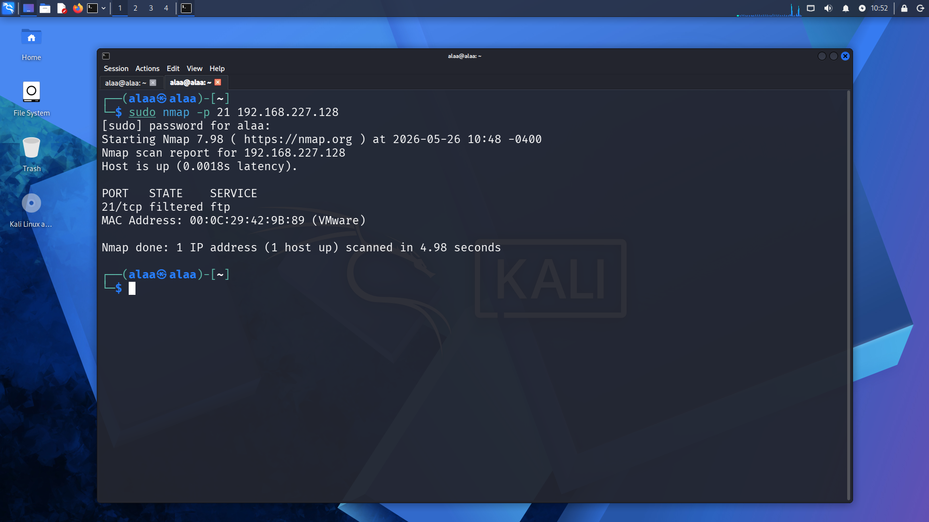
4.10 SSH Weak Configuration Vulnerability & Mitigation
Vulnerability & Impact:
Secure Shell (SSH) is a remote administration protocol that operates on TCP Port 22 and is widely used for secure remote access and system management. Although SSH is considered a secure protocol, weak configurations, poor password policies, or exposed services can still make the system vulnerable to unauthorized access attacks.
In this lab environment, the SSH service on the target machine was configured with weak security settings, allowing attackers to attempt remote authentication attacks against the server. Weak credentials and insecure configurations significantly increase the risk of unauthorized system access, privilege escalation, remote command execution, and full server compromise.
If attackers successfully gain SSH access, they can remotely control the target machine, execute administrative commands, manipulate files, install malicious software, and compromise sensitive system data.

Technical Exploitation Scenario
To simulate the attack scenario, the SSH service running on the Metasploitable target machine was accessed remotely from the Kali Linux attacker machine. Due to weak authentication configurations and insecure credential management, the attacker successfully established a remote SSH session with the target system.
After obtaining access, the attacker was able to interact directly with the operating system through the command-line interface and execute various system commands remotely. This demonstrated how weak SSH security configurations can expose critical systems to unauthorized remote administration attacks.
The successful connection confirmed that the SSH service was accessible externally and vulnerable to unauthorized access attempts.

Service Hardening and Firewall Mitigation
After demonstrating the vulnerability, several security hardening techniques were implemented to secure the SSH service against unauthorized access attacks.
The mitigation process included strengthening authentication policies, restricting remote access permissions, and applying firewall filtering rules to control access to TCP Port 22. These defensive measures significantly reduced the possibility of brute-force attacks, credential guessing, and unauthorized remote logins.
Additional protection mechanisms were applied to minimize the exposed attack surface and improve the overall security posture of the SSH service.

Experimental Verification & Defense Proof
To verify the effectiveness of the implemented mitigation, the attacker attempted to reconnect to the SSH service after the security controls were applied.
The verification results confirmed that unauthorized access attempts were successfully blocked by the updated security configurations and firewall restrictions. The SSH service no longer allowed insecure remote connections from unauthorized systems.
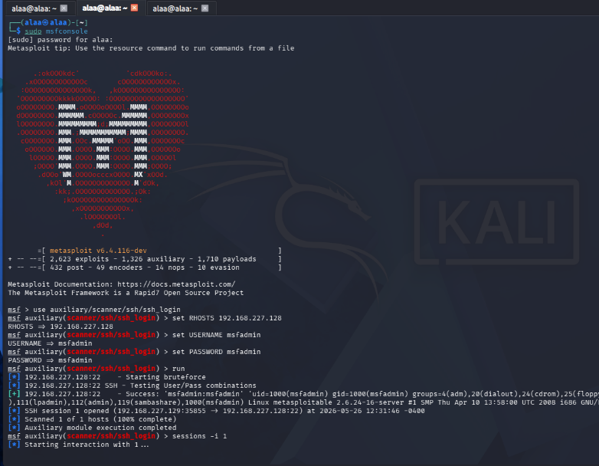
This demonstrated that the implemented hardening procedures effectively protected the target machine against remote SSH exploitation attempts and reduced the overall attack surface exposed to the network.

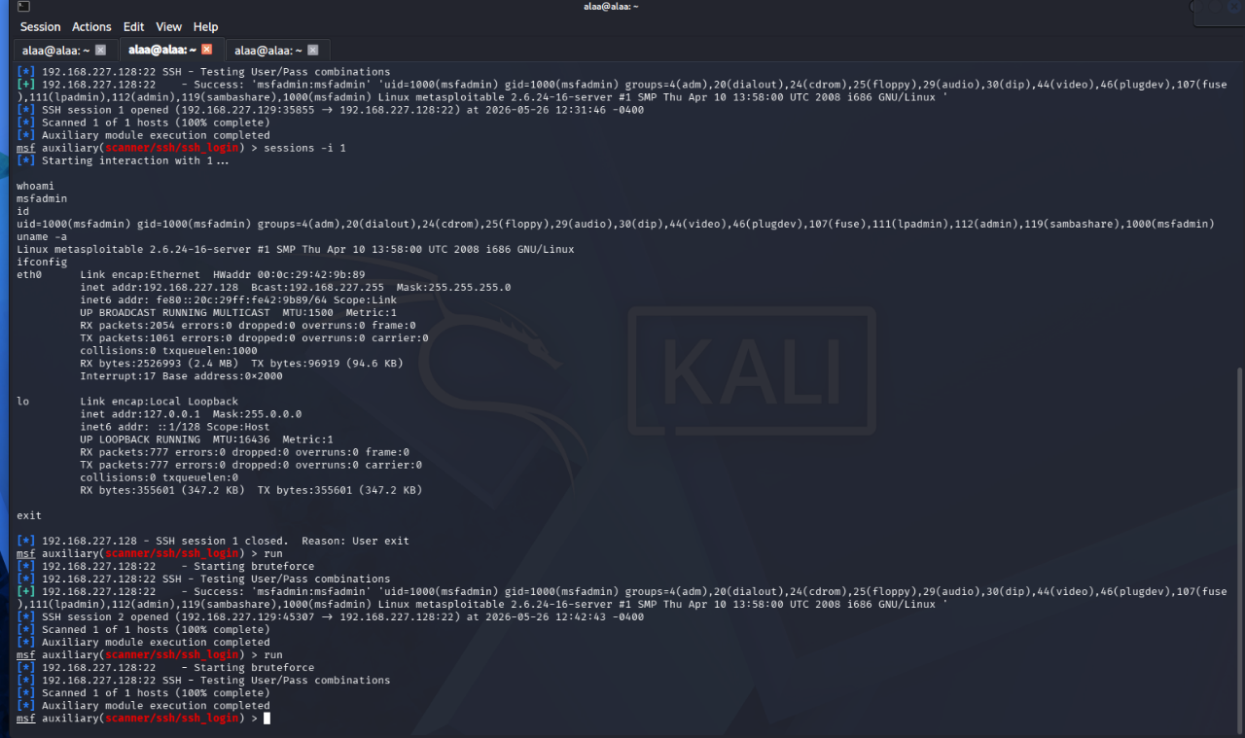
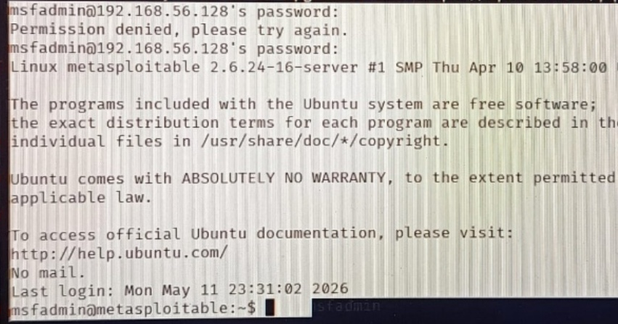

CHAPTER 5

THE GANTT CHART

Project Development Timeline
The following Gantt chart outlines the major phases of the Vulnerability Assessment and Penetration Testing Lab project. The project includes building a virtual cybersecurity environment, performing network scanning and vulnerability analysis, exploiting selected vulnerabilities, applying security hardening techniques, and documenting the final results. Each phase was completed over specific weeks to ensure proper planning, implementation, testing, and reporting.
Table 5.1 Gantt Chart Table

Task | Week 1 | Week 2 | Week 3
VMware & Host-Only Network Setup
Kali Linux & Metasploitable Configuration
Vulnerability Scanning using Nmap
Identifying Open Ports & Vulnerabilities
Fixing / Closing Vulnerabilities
Security Testing & Validation
Final Report & Documentation

Notes:
• The project was developed over 3 weeks.
• Vulnerability scanning and port analysis were performed using Kali Linux and Nmap.
• Open ports and detected vulnerabilities were identified and mitigated during the implementation phase.
• Re-scanning and security validation were completed after applying the fixes.
• Final documentation and reporting were completed in the last week.

CHAPTER 6

CONCLUSIONS

6.1 Conclusion Remarks
​This project successfully demonstrated a comprehensive implementation of a Vulnerability Assessment and Scanning Lab inside a secure, completely isolated virtualization infrastructure using a VMware Host-Only network layout. Through precise network reconnaissance utilizing Nmap, more than 10 distinct and critical security vulnerabilities were systematically identified, mapped, and cataloged across various core network protocols and services, including FTP, SSH, distccd, Apache Tomcat, Samba, MySQL, and VNC.
​The project effectively validated the dual-responsibility model of modern security engineering by executing controlled offensive simulations via frameworks like Metasploit and Hydra, followed immediately by defensive architecture hardening. Most importantly, the remediation phase successfully satisfied critical operational constraints; by deploying targeted host-based firewall rules via iptables and eradicating dangerous binary SUID permissions, the infrastructure's attack surface was fully minimized, and remote exploit vectors were neutralized without resorting to absolute service termination, thereby preserving the native uptime and continuous availability of internal enterprise workflows.

​6.2 Recommendations for Future Work
​While the established laboratory environment provided robust mitigation against network-layer and service-specific exploits, cybersecurity is an ever-evolving domain. To expand upon the findings of this project, the following avenues are highly recommended for future research and enhancements:
​Integration of Intrusion Detection/Prevention Systems (IDS/IPS): Future upgrades should integrate open-source defense utilities such as Snort or Suricata to actively monitor network traffic anomalies and trigger automated alerts upon scanning detection.
​Advanced Application-Layer Assessment: Expanding the lab's scope to evaluate modern web-tier architecture flaws, specifically covering the OWASP Top 10 vulnerabilities (such as SQL Injection and Cross-Site Scripting - XSS).
​Automated SIEM Centralization: Deploying a Security Information and Event Management (SIEM) system (e.g., Wazuh or the ELK Stack) to collect, aggregate, and analyze log transactions from host operating systems and firewalls in real-time.
​Defensive DevSecOps and Patch Automation: Researching the automation of security patching sequences using configuration management tools like Ansible to patch outdated network daemons dynamically before external auditing phases.

REFERENCES
1. Nmap Project Nmap Network Scanning Official Guide
https://nmap.org/book/

2. Rapid7 Metasploit Module vsftpd 2.3.4 Backdoor
https://www.rapid7.com/db/modules/exploit/unix/ftp/vsftpd_234_backdoor/

3. Apache Software Foundation Apache Tomcat Official Documentation
https://tomcat.apache.org/

4. Samba Team Samba Documentation and Wiki
https://www.samba.org/samba/docs/

5. Oracle Corporation, MySQL Reference Manual
https://dev.mysql.com/doc/refman/8.0/en/

6. Netfilter Project The Packet Filtering HOWTO (iptables)
https://www.netfilter.org/documentation/HOWTO/packet-filtering-HOWTO.html

7. Linux Documentation Project GNU/Linux Tools Summary – File Permissions and SUID
https://tldp.org/LDP/GNU-Linux-Tools-Summary/html/x1165.htm
جامعة اسفنكس باسيوط الجديدة
كلية علوم الحاسب والذكاء الاصطناعي
تحت إشراف
م/ اكرام عبد الوهاب
م/ احمد حسين
تم تقديمه كجزء من متطلبات مشروع المستوى الثاني في كلية الحاسبات والمعلومات
2026-2025
جامعه سفنكس بأسيوط الجديدة
كلية علوم الحاسب والذكاء الاصطناعي
تقييم الثغرات الأمنية وفحصها
PRESENTED BY:
ميران ناجح ابراهيم | 4241081
سلمى اشرف ابراهيم محمد | 4241373
بلال عبد العال عبد الهادى | 4241376
علاء مرتجى كمال وحيش | 4241388
تغريد حسن محمد | 4241180
بثينة الحسين عبد الراضى | 4241047

تحت إشراف
م/ اكرام عبد الوهاب
م/ احمد حسين

تم تقديمه كجزء من متطلبات مشروع المستوى الثاني في كلية الحاسبات والمعلومات
2026-2025

